Lab 4 – My Solutions
3.1.1
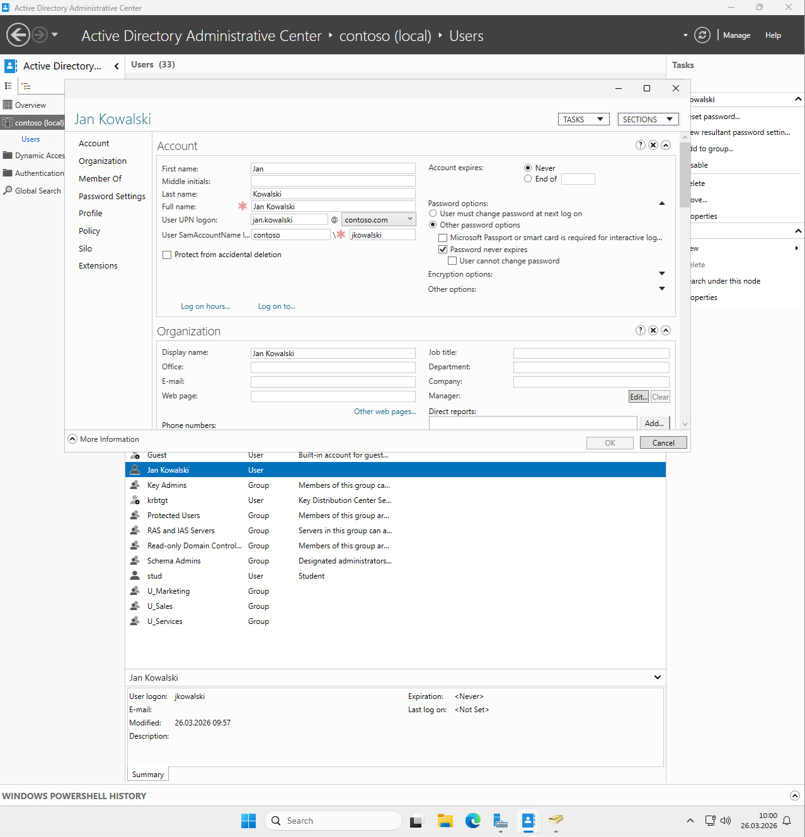

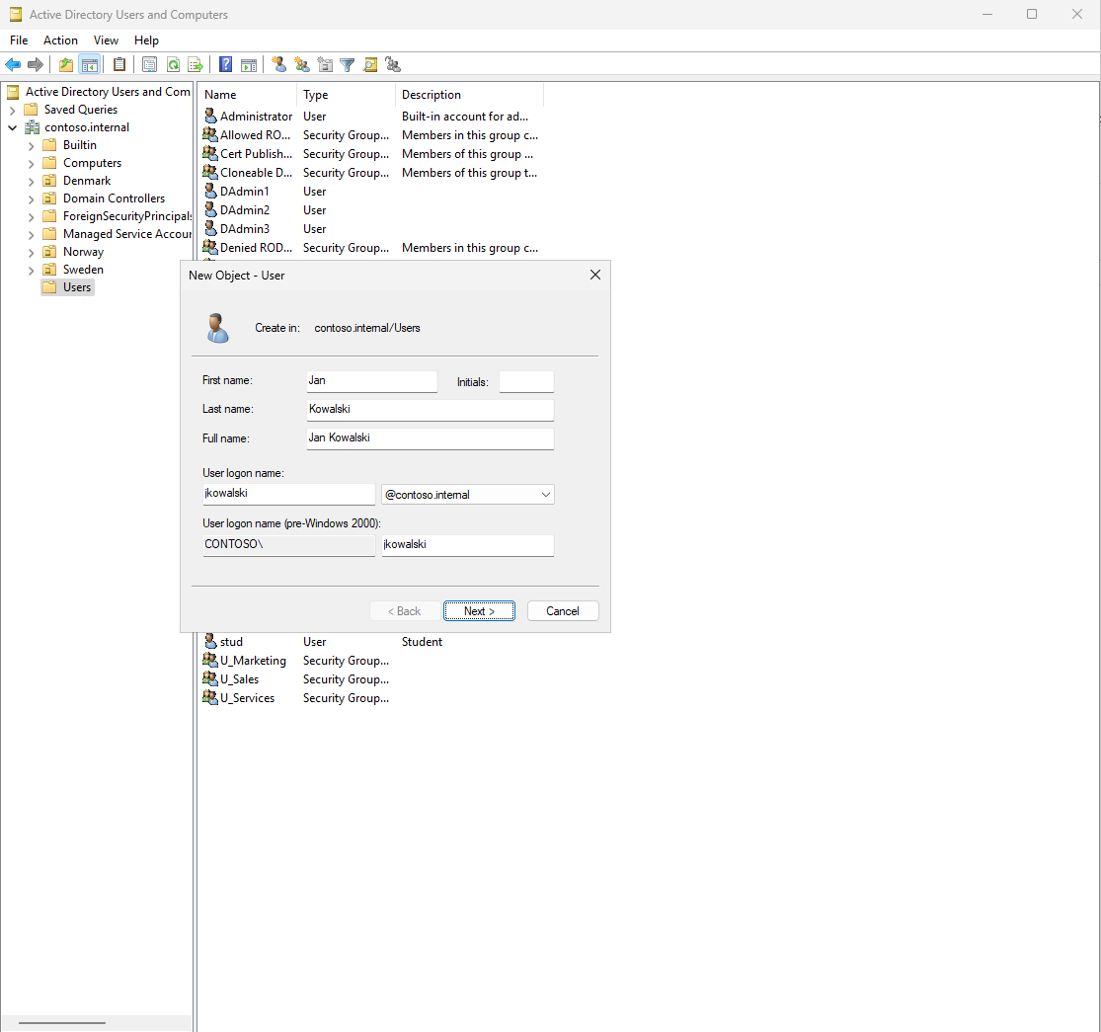

CMD:
dsadd user "CN=Jan Kowalski,OU=Users,DC=contoso,DC=internal" ^
-fn Jan ^
-ln Kowalski ^
-display "Jan Kowalski" ^
-upn jan.kowalski@contoso.com ^
-samid jkowalski ^
-pwd MyPassword1 ^
-mustchpwd no ^
-disabled no

PowerShell:
New-ADUser `
-Name "Jan Kowalski" `
-GivenName "Jan" `
-Surname "Kowalski" `
-DisplayName "Jan Kowalski" `
-UserPrincipalName "jan.kowalski@contoso.com" `
-SamAccountName "jkowalski" `
-Path "OU=Users,DC=contoso,DC=internal" `
-AccountPassword (ConvertTo-SecureString -AsPlainText "MyPassword1" -Force) `
-Enabled $True

3.1.2
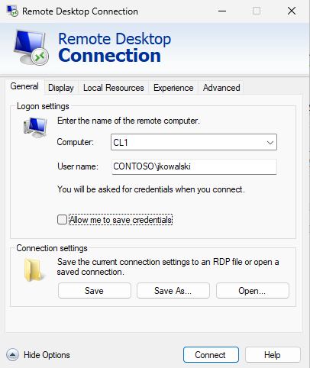
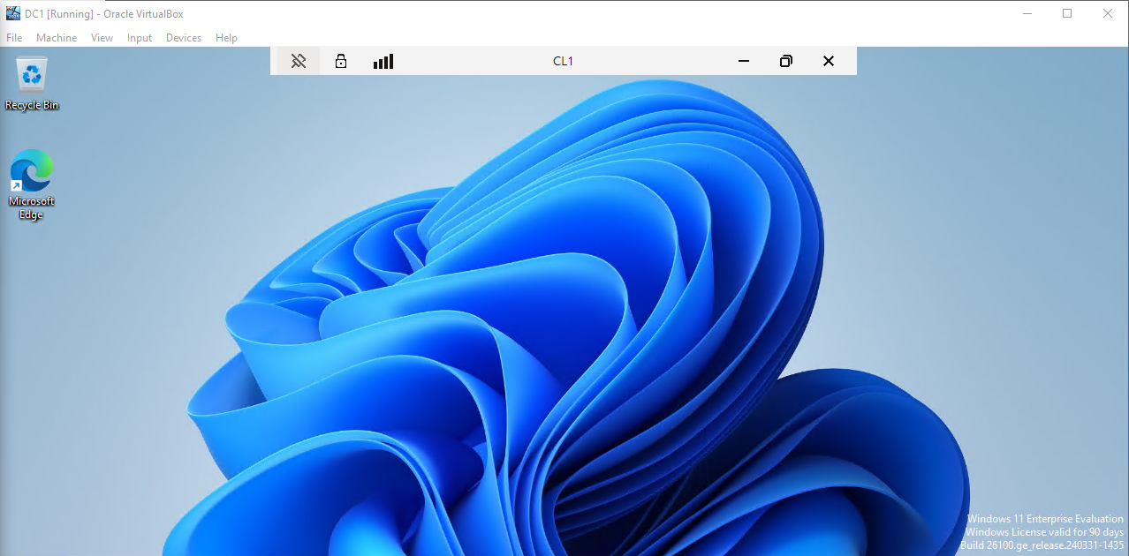
PS C:\Users\Administrator> Set-ADUser -Identity jkowalski `
>> -OfficePhone "+48123456789" `
>> -Office "Room 101" `
>> -HomeDirectory "C:\Users\jkowalski" `
>> -City "Warsaw" `
>> -Country "PL"

3.1.3
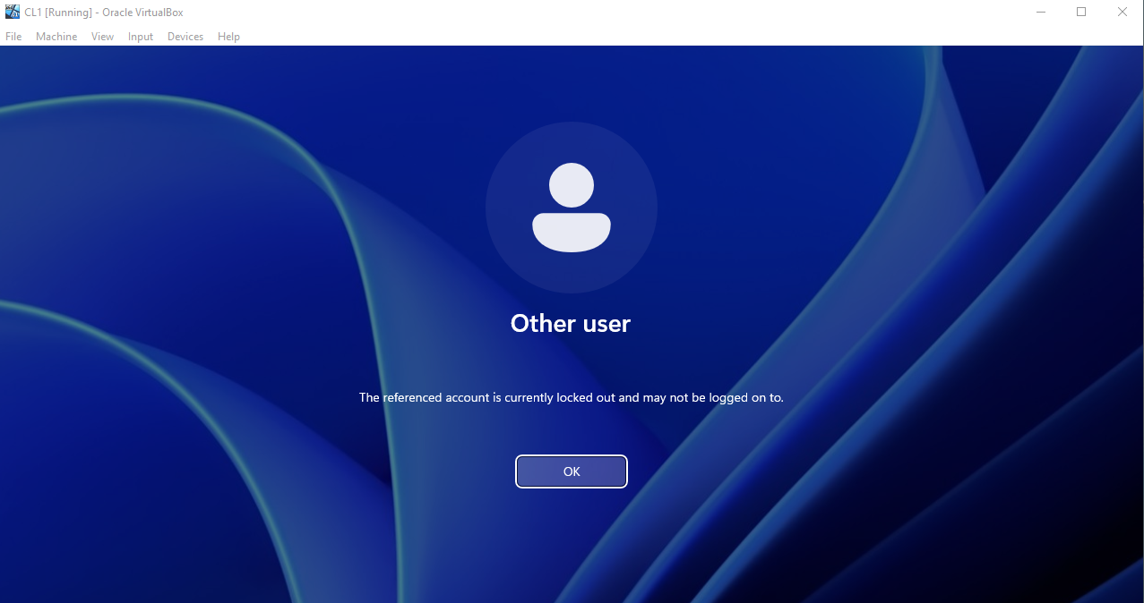
Enable-ADAccount -Identity jkowalski
Or
Unlock-ADAccount -Identity jkowalski

4.2
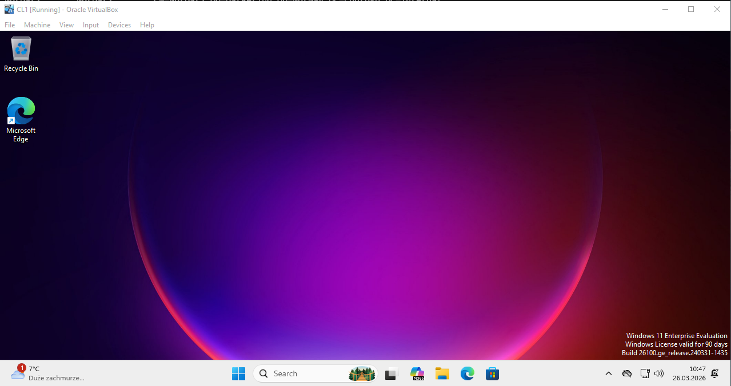
4.3
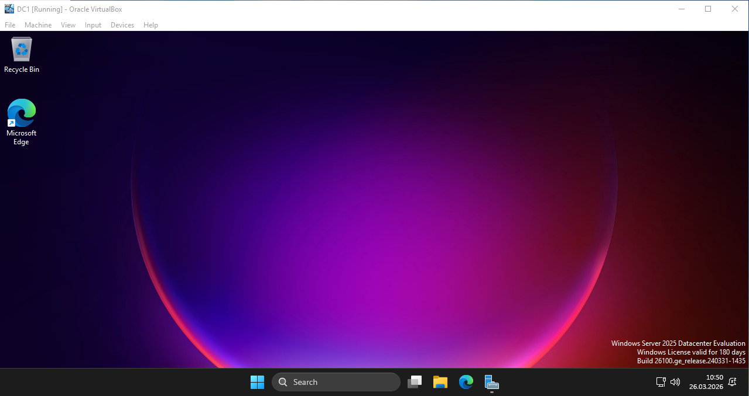

5:
PS C:\Users\Administrator> New-ADGroup -Name "GlobalGroup1" `
>> -GroupScope Global `
>> -GroupCategory Security `
>> -Path "OU=Sales,OU=Sweden,DC=contoso,DC=internal"
PS C:\Users\Administrator> New-ADGroup -Name "LocalGroup1" `
>> -GroupScope DomainLocal `
>> -GroupCategory Security `
>> -Path "OU=Sales,OU=Sweden,DC=contoso,DC=internal"
PS C:\Users\Administrator> New-ADGroup -Name "UniversalGroup1" `
>> -GroupScope Universal `
>> -GroupCategory Security `
>> -Path "OU=Sales,OU=Sweden,DC=contoso,DC=internal"
PS C:\Users\Administrator> Add-ADGroupMember -Identity "GlobalGroup1" -Members jkowalski
PS C:\Users\Administrator> Add-ADGroupMember -Identity "UniversalGroup1" -Members "GlobalGroup1"
PS C:\Users\Administrator> Get-ADGroup -Filter * `
>> -SearchBase "OU=Sales,OU=Sweden,DC=contoso,DC=internal" | `
>> Select-Object Name, GroupScope, GroupCategory

Name GroupScope GroupCategory
---- ---------- -------------
G_Sweden_Sales Global Security
GlobalGroup1 Global Security
LocalGroup1 DomainLocal Security
UniversalGroup1 Universal Security

PS C:\Users\Administrator> Get-ADGroupMember -Identity "GlobalGroup1" | Select-Object Name, SamAccountName, objectClass

Name SamAccountName objectClass
---- -------------- -----------
Jan Kowalski jkowalski user

PS C:\Users\Administrator> Get-ADPrincipalGroupMembership -Identity jkowalski | Select-Object Name, GroupScope

Name GroupScope
---- ----------
Domain Users Global
Remote Desktop Users DomainLocal
Domain Admins Global
GlobalGroup1 Global

